Using the best performing workflows as well as with the help of Computer Vision Toolbox, identified the boundaries of the number plate and then cropped the number plate from the larger image. This is performed automatically; no coordinates were provided to the program!

The sequence is as follows: load the image, perform a multiplication of (RGB\*BinaryImg), find the ImgSizes of the bounding box, crop the desired section of the img, binarizing the newly created cropped section, applying the OCR Function to identify the plate and finally display OCR results along with exporting the outputs.

Below is final result shown in Fig6.2 as for Fig6.1 we can see the program using OCR Function clearly identifying the correct numberplate i.e. LR33TEE. The same method can be applied to Q7 for pictures as every time I tested the method on other picture samples it was always identifying the correct numberplate readings.

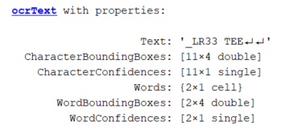

Figure 6.1 – OCRText Display



Figure 6.2 – SquareFour (imclose at Size 10) – Tested Sample